**Opening Up the App**

1. Clone the repo from GitHub: <https://github.com/trevorgray5/DarkWebCrusaders>
2. Navigate to the ./Express-App folder: cd .\Express-App\
3. The node_modules folder is not saved to our repo. Run npm i
4. Once complete, assuming everything goes well, you can start the application: node app.js
5. Now you should be able to open the following link to <http://localhost:3000/>

*These are the steps each of us has tested and used to run our application, but as we have experienced, the node package management system is very unpredictable. Please reach out if you have any issue starting the application.

**How to Navigate in the App**

Main Page:

* A button to Add Task
* A section for your tasks to sit 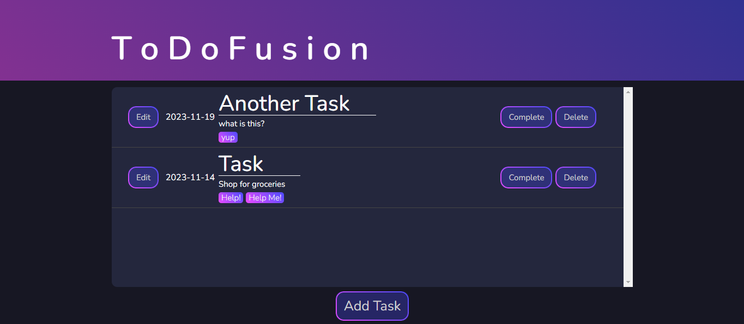

Add Task Button:

* After clicking the Add Task button a popup window will appear
  + Here you can Enter the title, description, due date, and any related tags for your task.
    - Enter the due date in the format MM/DD/YYYY
    - When entering more than one tag, use a comma between each tag.
* Click the submit button to post your task to the screen.
* If you decide you do not need the task you are entering information in for, click the ‘x’ in the top right corner to exit the popup. 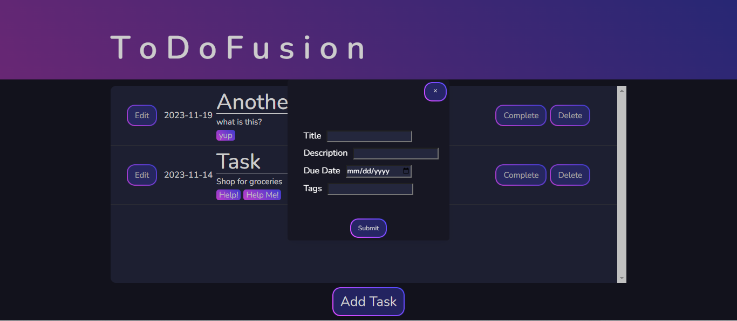

Task Card:

* Upon submitting your task, they will appear on screen in the order in which you created them. **For Example:**

Task 1

Task 2

Task 3

* Each Task you create will have an Edit button on the left side, a delete and complete button on the right, and the information you entered in the center of the card.

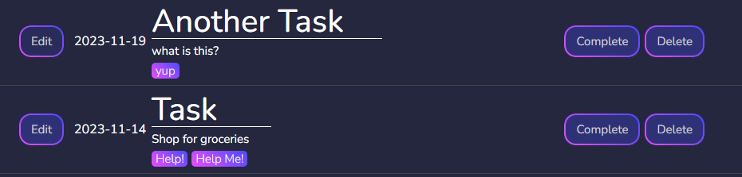

Edit Button:

* After clicking the edit button, textboxes will appear with your existing data.
  + Change the data to what you wish and click the save button.
* The save button will override the task you edited to now show your updated task.

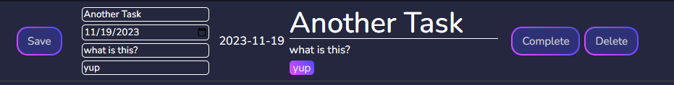

Delete Button:

* Clicking the delete button will remove the task from the list.
  + BE CAREFUL, THERE IS NO UNDOING THIS!!

Complete Button:

* After completion of a task, if you do not want to fully delete it, you may mark it as complete
  + This will cross out all of your data and change the button from “Complete to “Uncomplete”
    - If you realize you need to continue working on the task, click the “Uncomplete” button and it will unmark all of your data and the button text will change back to “Complete”

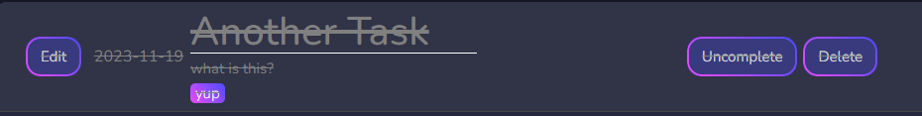

Notes:

* This application is shared between users, meaning you and other people will see the same tasks.